https://supabase.com/dashboard/new
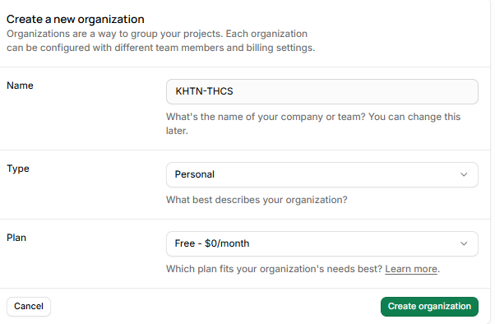
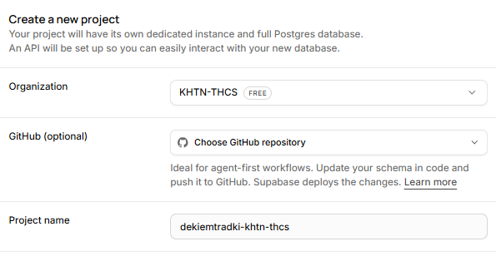
Project name: dekiemtradki-khtn-thcs
Database password: Thanh@de1khtn-thcs

